Week – 1
Session 1
import java.io.*;
import java.util.*;
interface PerformOperation {
boolean check(int a);
}
class MyMath {
public static boolean checker(PerformOperation p, int num) {
return p.check(num);
}
public static PerformOperation isOdd() {
return n -> n % 2 != 0;
}

public static PerformOperation isPrime() {
return n -> {
if (n < 2)
return false;

for (int i = 2; i * i <= n; i++) {
if (n % i == 0)
return false;
}
return true;
};
}

public static PerformOperation isPalindrome() {
return n -> {
int original = n;
int reverse = 0;

while (n > 0) {
reverse = reverse * 10 + (n % 10);
n /= 10;
}

return original == reverse;
};
}
}

public class Solution {

public static void main(String[] args) throws IOException {
MyMath ob = new MyMath();
BufferedReader br = new BufferedReader(new InputStreamReader(System.in));
int T = Integer.parseInt(br.readLine());
PerformOperation op;
boolean ret = false;
String ans = null;
while (T--> 0) {
String s = br.readLine().trim();
StringTokenizer st = new StringTokenizer(s);
int ch = Integer.parseInt(st.nextToken());
int num = Integer.parseInt(st.nextToken());
if (ch == 1) {
op = ob.isOdd();
ret = ob.checker(op, num);
ans = (ret) ? "ODD" : "EVEN";
} else if (ch == 2) {
op = ob.isPrime();
ret = ob.checker(op, num);
ans = (ret) ? "PRIME" : "COMPOSITE";
} else if (ch == 3) {
op = ob.isPalindrome();
ret = ob.checker(op, num);
ans = (ret) ? "PALINDROME" : "NOT PALINDROME";

}
System.out.println(ans);
}
}
}
Output:-
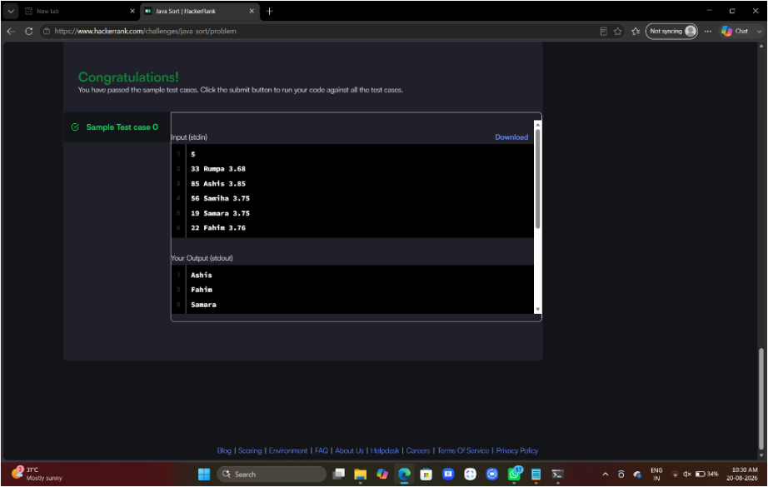

Session 2
import java.util.*;
class Student{
private int id;
private String fname;
private double cgpa;
public Student(int id, String fname, double cgpa) {
super();
this.id = id;
this.fname = fname;
this.cgpa = cgpa;
}
public int getId() {
return id;
}
public String getFname() {
return fname;
}
public double getCgpa() {
return cgpa;
}
}public class Solution
{
public static void main(String[] args){
Scanner in = new Scanner(System.in);
int testCases = Integer.parseInt(in.nextLine());
List<Student> studentList = new ArrayList<Student>();
while(testCases>0){
int id = in.nextInt();
String fname = in.next();
double cgpa = in.nextDouble();
Student st = new Student(id, fname, cgpa);
studentList.add(st);
testCases--;
}
Collections.sort(studentList, (s1, s2) -> {
if (Double.compare(s2.getCgpa(), s1.getCgpa()) != 0) {
return Double.compare(s2.getCgpa(), s1.getCgpa());
} else if (!s1.getFname().equals(s2.getFname())) {
return s1.getFname().compareTo(s2.getFname());
} else {
return Integer.compare(s1.getId(), s2.getId());
}
});
for(Student st: studentList){
System.out.println(st.getFname());
}
}
}
Output:-
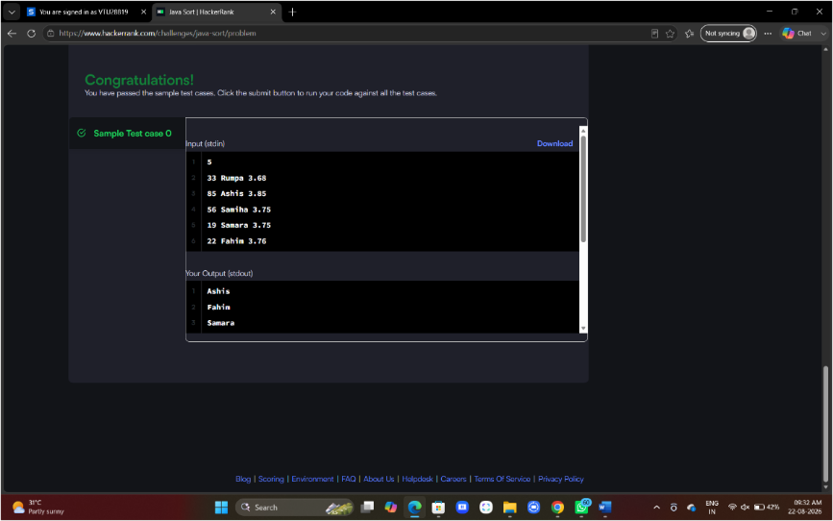

Task 2
class Solution {
public int[] sortArrayByParity(int[] nums) {

int[] result = new int[nums.length];
int index = 0;

// Add even numbers first
for (int num : nums) {
if (num % 2 == 0) {
result[index++] = num;
}
}

// Add odd numbers next
for (int num : nums) {
if (num % 2 != 0) {
result[index++] = num;
}
}

return result;
}
}
Output:-
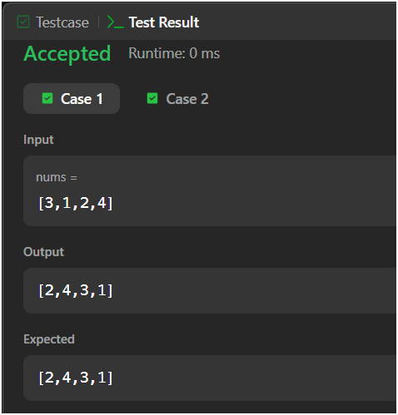
Session 3
Task 1
mport java.util.*;
class Player {
String name;
int score;
Player(String name, int score) {
this.name = name;
this.score = score;
}
}
class Checker implements Comparator<Player> {
public int compare(Player a, Player b) {
if (a.score != b.score) {
return b.score - a.score;
}
return a.name.compareTo(b.name);
}
}
public class Solution {
public static void main(String[] args) {
Scanner scan = new Scanner(System.in);
int n = scan.nextInt();\
Player[] player = new Player[n];
Checker checker = new Checker();

for(int i = 0; i < n; i++){
player[i] = new Player(scan.next(), scan.nextInt());
}
scan.close();
Arrays.sort(player, checker);
for(int i = 0; i < player.length; i++){
System.out.printf("%s %s\n", player[i].name, player[i].score);
}
}
}
Output :-
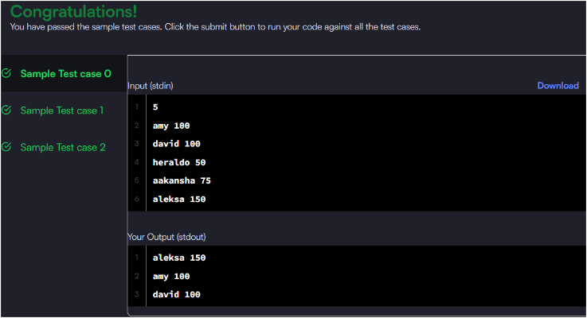
Task 2
mport java.util.*;
class Checker implements Comparator<Player> {

@Override
public int compare(Player a, Player b) {

// Higher score first
if (a.score != b.score) {
return b.score - a.score;
}

// Same score: alphabetical order
return a.name.compareTo(b.name);
}
}

// Write your Checker class here

class Player{
String name;
int score;

Player(String name, int score){
this.name = name;
this.score = score;
}
}

class Solution {

public static void main(String[] args) {
Scanner scan = new Scanner(System.in);
int n = scan.nextInt();

Player[] player = new Player[n];
Checker checker = new Checker();

for(int i = 0; i < n; i++){
player[i] = new Player(scan.next(), scan.nextInt());
}
scan.close();

Arrays.sort(player, checker);
for(int i = 0; i < player.length; i++){
System.out.printf("%s %s\n", player[i].name, player[i].score);
}
}
}
Output :-
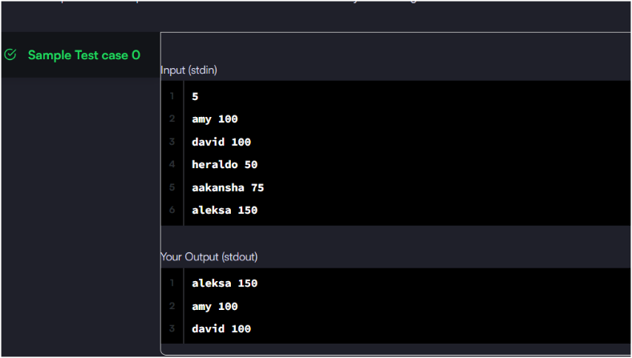
Session 4
Task 1
class Solution {
public int[] runningSum(int[] nums) {
for (int i = 1; i < nums.length; i++) {
nums[i] = nums[i] + nums[i - 1];
}

return nums;
}
}
Output:-
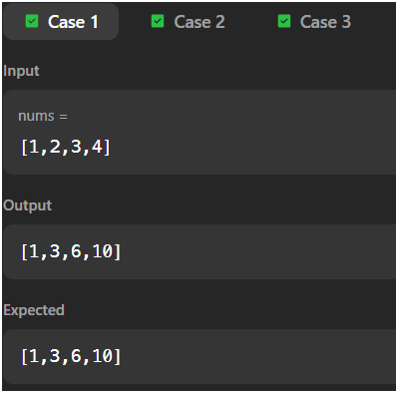
Task 2
class Solution {
public int maximumWealth(int[][] accounts) {
int maxWealth = 0;
for (int i = 0; i < accounts.length; i++) {
int wealth = 0;
for (int j = 0; j < accounts[i].length; j++) {
wealth += accounts[i][j];
}
if (wealth > maxWealth) {
maxWealth = wealth;
}
}

return maxWealth;
}
}
Output:-
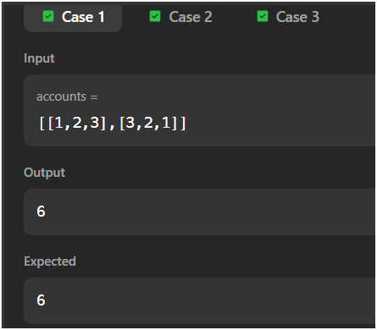
Session 5
Task 1
class Solution {
public int[] sortedSquares(int[] nums) {
int n = nums.length;
int[] result = new int[n];
int left = 0;
int right = n - 1;
for (int i = n - 1; i >= 0; i--) {
if (Math.abs(nums[left]) > Math.abs(nums[right])) {
result[i] = nums[left] * nums[left];
left++;
} else {
result[i] = nums[right] * nums[right];
right--;
}
}
return result;
}
}
Output:-
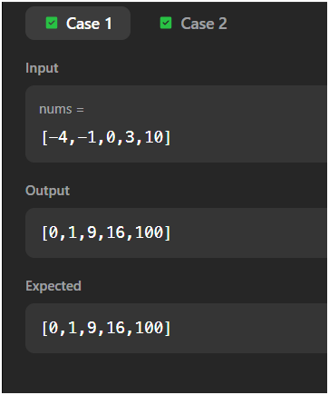
Task 2
class Solution {
public int pivotIndex(int[] nums) {
int totalSum = 0;
// Calculate total sum
for (int num : nums) {
totalSum += num;
}
int leftSum = 0;
for (int i = 0; i < nums.length; i++) {
// Right sum = total - left - current
int rightSum = totalSum - leftSum - nums[i];
if (leftSum == rightSum) {
return i;
}
leftSum += nums[i];
}
return -1;
}
}
Output :-
